**Effect of State Regulations on Opioid Shipment and Overdose Deaths**

Xiaoyu Chen, Raza Lamb, Roza Ogurlu, Robert Wan

1. **Introduction**

**1.1** The motivation for the project:

The country is in the midst of an opioid-related public health crisis, characterized by increased opioid misuse and dependence and accompanying sequalae, including fatal opioid overdose. National survey estimates indicate that in 2018 nearly 10 million people misused prescription opioids, approximately 800,000 used heroin, and 2 million people had an opioid use disorder (OUD). In response, states and the federal governments have enacted a broad array of policies, the motivation for this project is to quantify the impact of those policy changes in comparison to places where such policy changes didn't take place, to determine whether and to what extent these policies have addressed the current problems, and whether the policy changes can inform the development of more effective policies in the future. The context of this project is the increase in drug addiction and prescription opioid overdose deaths in the US in the past two decades. In this project, we'll measure the effect of a series of policy changes designed to limit abuse of prescription opioid drugs and mortality from drug overdoses. Three policies we will be focusing on were effective in Florida, Texas, and Washington in 2010, 2007 and 2012, respectively.

**1.2** Overview of the data being used:

Three datasets that were used in the analysis were:

1. All opioid prescription drug shipments in the US from 2006-2012 (from US Drug Enforcement Agency, requested by Washington Post).
2. Mortality due to drug and non-drug-related causes in the US from 2003-2015 (from US Vital Statistics records).
3. Population and population estimates for each US county from 2003-2015 (from US Census).

## **Analysis Methods:**

2.1 Summary

We have opioid shipment data for Florida only and opioid overdose death data for Florida, Washington, and Texas. The measured metrics are shipment and overdose death for Florida and only overdose death for Washington and Texas. We employed two methodologies to investigate the effect of opioid drug prescription regulations on the volume of opioid shipment and drug overdose deaths. First, we compared the trend of shipment/mortality before and after the regulations went into effect – this method is known as a pre-post comparison. Next, we looked at the change in the trend of the metrics before and after the regulations and compared it with the change in the direction of similar counties – this method is known as difference-in-difference.

2.2 High-Level Explanation of Methodologies

The pre-post comparison provides a straightforward way to visualize the effect of the regulations of opioid. Using this method, one can easily discern changes in trends before and after the regulations went into effect. However, it does not provide context for such observed changes in trends. For instance, it is unclear if changes in trends were due to the regulations or something else that happened to occur at the same time.

In comparison, the difference-in-difference selects similar counties from other states to act as the “control group”. Similar counties were selected in a way that their trends of shipment / mortality before the regulations were similar to those of Florida, Washington, or Texas. We assume that if the regulations had not been implemented in those three states, their trends of shipment / mortality would have followed the same path as those of the control group. By comparing the trends of the three states with the trends of the control groups after the regulations, we can get closer to measuring the true effect of the regulations.

2.3 Time Period

The pre-period of each analysis includes all years before the regulation took effect in the state. The year that the regulation took effect and onwards are the post-period. Each of the three states we investigated implemented regulations in different years. In addition, the opioid shipment and drug overdose death data sets we used to cover different time periods. As such, the pre-and post-periods for each analysis are different.

We have laid out the pre-and post-periods for each analysis below to clarify the periods of each analysis.

Table 1 periods of each analysis

1. **Analysis Results**

3.1 Pre-Post Analysis

For this analysis, we simply observed at the trend in either opioid prescription shipments or opioid overdoses in states with a policy change, in the years before and after that policy change. Therefore, four relevant graphs were generated: opioid shipments in Florida, and opioid overdoses in Florida, Texas, and Washington, individually. These graphs visually demonstrate whether or not there was a change in the trend of opioid shipments or mortality per year before and after the state's policy change.

3.1.1 Florida Analysis (Mortality & Shipment)

First off, figure 1 and 2 included are both opioid shipments per capita and mortality per capita before and after a significant policy change in 2010.

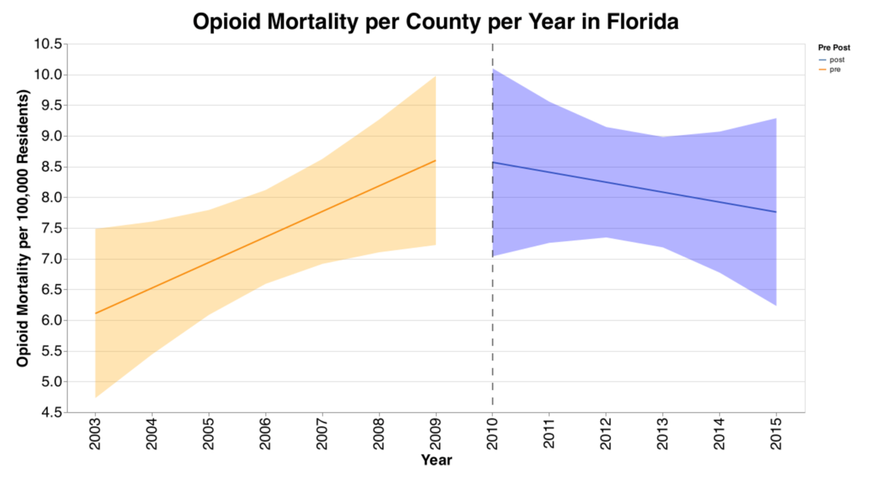

Figure opioid mortality per county per year in Florida

Figure opioid shipments per county per year in Florida

Interestingly, there is a clear increasing trend in both opioid shipments and opioid mortality before 2010, which is reversed. However, as visualized by the 95% confidence bands, there is more significant uncertainty (i.e., more spread) in the mortality data. This is likely because the vast majority of counties have less than ten opioid mortality deaths per year, which are unreportable and represented as zeros in our dataset. Overall, from these graphs, we can assert relatively confidently that there was a change in the trend of opioid shipments per capita in Florida after the policy change, and mortality also appears to display a different trend. Still, we are less confident due to the more significant error bands.

3.1.2 Texas & Washington Analysis (Mortality)

Next, displayed are opioid mortality trends in Texas and Washington, again, before and after policy changes.

Figure opioid mortality per county per year in Texas

Figure opioid mortality per county per year in Washington

Visibly, the results here are not as clear. There is a step-increasing trend in mortality in Texas before the policy change (2007) and a much flatter trend. While the evidence is not clear enough to say there is a reversal in the trend, the increase is at least dampened. In Washington, on the other hand, there is visibly minimal evidence that the trend in opioid mortality was altered at all after the policy change. While the confidence band is wide, the movement itself is nearly identical.

3.2 Difference-in-Difference Analysis

While the trends above are an important part of the story, the pre-post analysis does not take into account any other confounders that could be happening at a national level, also influencing either opioid shipments or mortality. For example, it's possible that the difference in trend witnessed Florida, could be happening nationally, in which case it would be inappropriate to conclude that the observed difference was caused by Florida's specific policy change. To account for this possibility, we also conducted a difference-in-difference analysis, in which we visualize the same pre-post analysis for the policy change state, but also include a selection of control counties. As previously, there are the same four graphs, but in this case, the graphs also include the selected control counties before and after the policy change.

3.2.1 Florida Analysis (Mortality & Shipment) VS Controls

Below are graphs for Florida, for both mortality and shipment data. The pre-post lines representing Florida are exactly the same as above, but these graphs also contain the selected control counties. It is evident that the general generally continues in the control counties, directly supporting the previous conclusion from the pre-post analysis.

Figure opioid mortality per county per year in Florida vs. controls

Figure opioid shipment per county per year in Florida vs. controls

3.2.2 Texas & Washington Analysis (Mortality) VS Controls

Similarly, below are the graphs for mortality in Texas and Washington. For Texas, the change in the increasing trend previous to the policy change is much more visible when compared with the control. In Washington's graph, interestingly, it is evident that in the control states, the increase in opioid mortality is generally larger after 2011. This suggests that while Washington's policy change may have not directly altered the trend, it may have limited an even more dramatic increase in mortality observed in counties with similar trends before the policy trend.

Figure opioid mortality per county per year in Texas vs. controls

Figure opioid mortality per county per year in Washington vs. controls

1. **Conclusion**

### 4.1 Discussion

### This study addresses data on opioid lethality and opioid shipments in 3 states between 2005-2018 in regards to the impact of opioid restriction policies after their release. We assessed the effect of these policies to some extent by comparing the variable control states, with the effectiveness of the policies in Florida reflected in a clear downward trend in the data after release. In Washington, Texas, the situation may support the possibility that the bills in these two areas are less effective.

### 4.2 Limitations of the current study

### Given that our learning objective is the mortality and transport of opioids for different counts, we face some limitations. The first is the lack of data. Most of the counts with mortality rates below ten were added as 0 possibly affecting the representation of part of the trend. The limitations of the data are also reflected in the fact that if we want to analyze the effectiveness of policies, it is necessary to include more policy categories to represent. It is clear that policies of different types and intensities are unlikely to have similar results. Comparing shipments, data on whether prescription opioids were used for consumption in institutions such as hospitals could be added to the discussion. In particular, policy and control groups may have different trends in outcomes over time, or the composition of state populations may change significantly over time. While the most common approach is regression adjustment. However, more robust models should be considered to assess.

### The field still faces significant methodological challenges and considerations, including standardized classification of opioid policies, identifying optimal control groups, and tightly controlling for differences between policy and control groups, and identifying variables that better capture the impact of policies. Improving the methodology of opioid policy evaluation studies is critical to the final government being able to implement policies that are most effective in reducing opioid harm.